

DESSERT

Ekmek Cheesecake $14
blueberry lemon, kataifi, whipped cream

Mosaiko $14
bittersweet chocolate, petit beurre biscuits, walnuts, bourbon, pastry cream

Baklava $8
pistachio, phyllo, orange blossom syrup

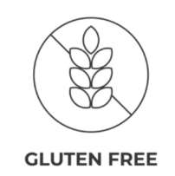
Portokolopita $14
orange upside-down cake, blood orange gelee,
whipped cream

GREEK AFTER DINNER SPIRITS

Metaxa 5yr…………………………$12

Metaxa 7yr………………….……..$14

Katsaros Oak Aged Tsipouro…..$16

KEO St. John Commandaria……$12


ATOMIC COFFEE ROASTERS STEVEN SMITH TEA



Coffee $4
Espresso $4
Cappuccino $5
Spring Greens: Green Tea $5
Lord Bergamot Black Tea $5
Peppermint Tea: Caffeine Free $5
Meadow Chamomile: Herbal $5

